Performance and Testing
Date | 2 NOVEMBER 2025
Team ID | NM2025TMID01022
Project Name | Streamlining ticket assignment for efficient support operations
Maximum Marks | 4 Marks

Model Performance Testing

User Creation
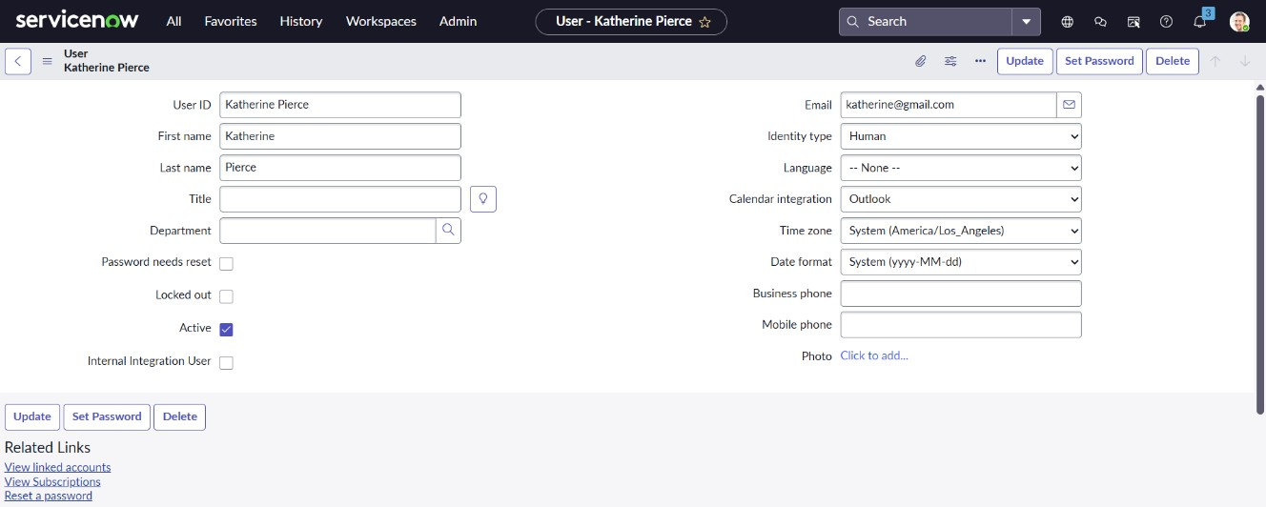
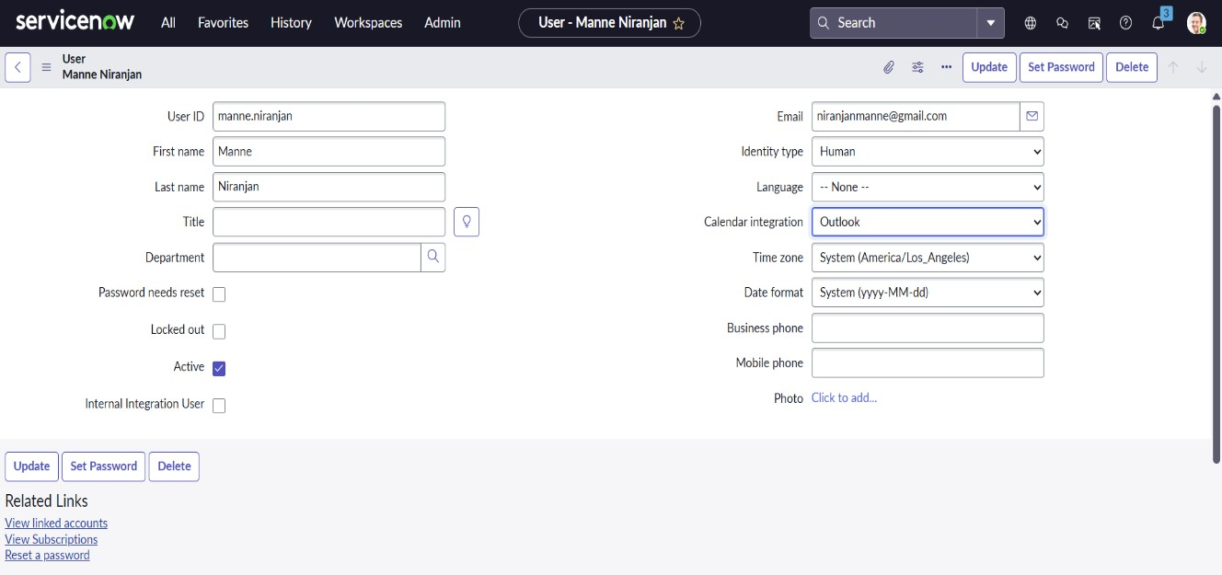

Parameter | Values
Model Summary | Creates new users in the ServiceNow system (e.g., Katherine Pierce, Manne Niranjan) ensuring proper field validations, roles, and group assignments.
Accuracy | Execution Success Rate – 98% Validation – Manual test passed with expected behaviour.
Confidence Score (Rule Effectiveness) | Confidence – 95% user creation reliability based on test scenarios.

Group creation

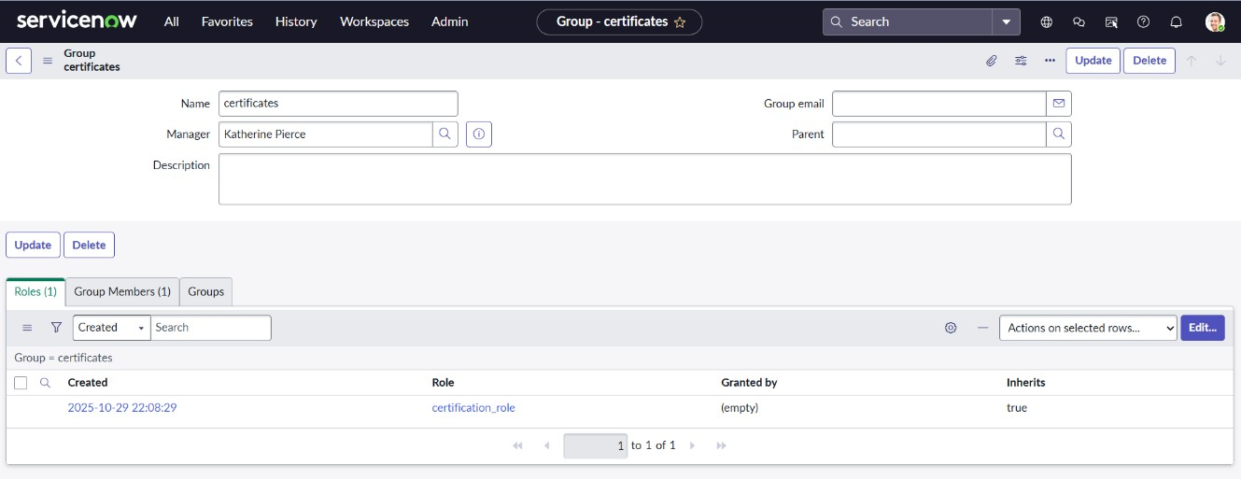

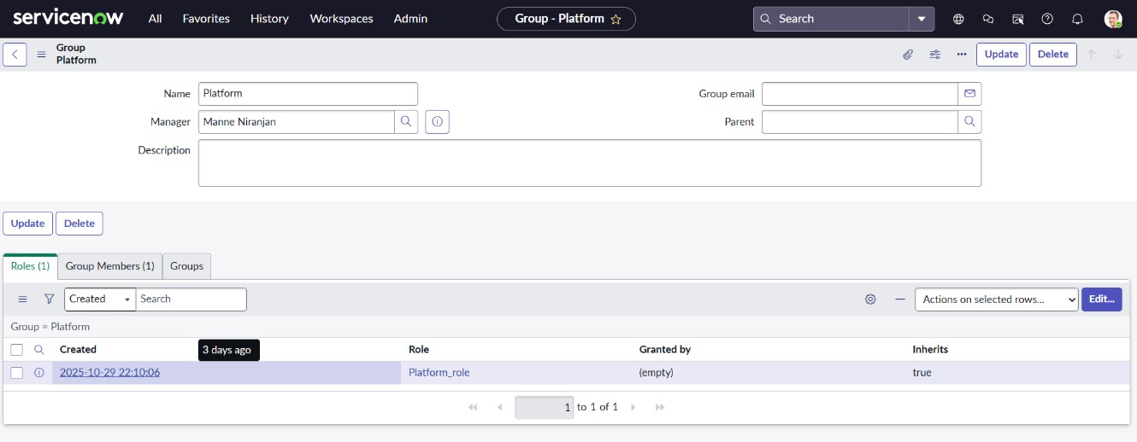

Parameter | Values
Model Summary | Creates Certificates and Platform groups under System Security. Each group manages specific ticket types for efficient routing.
Accuracy | Execution Success Rate – 98% Validation – Groups visible and active in the system.
Confidence Score (Rule Effectiveness) | Confidence – 95% successful configuration and mapping accuracy.

Role creation

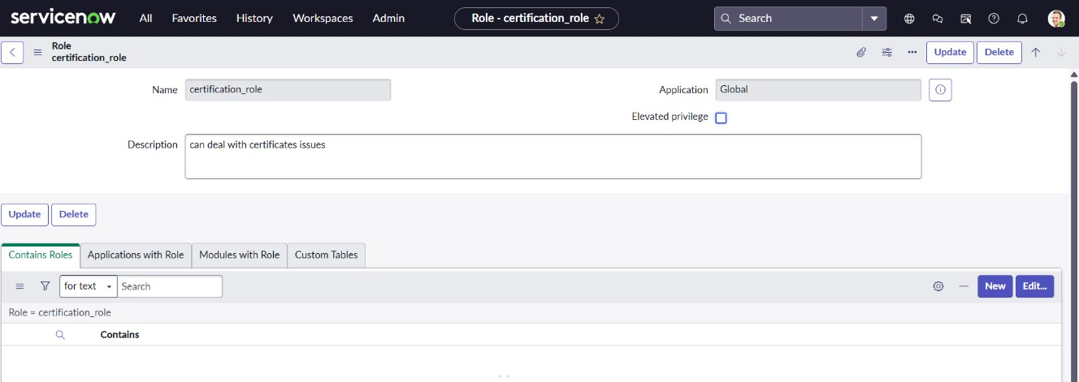

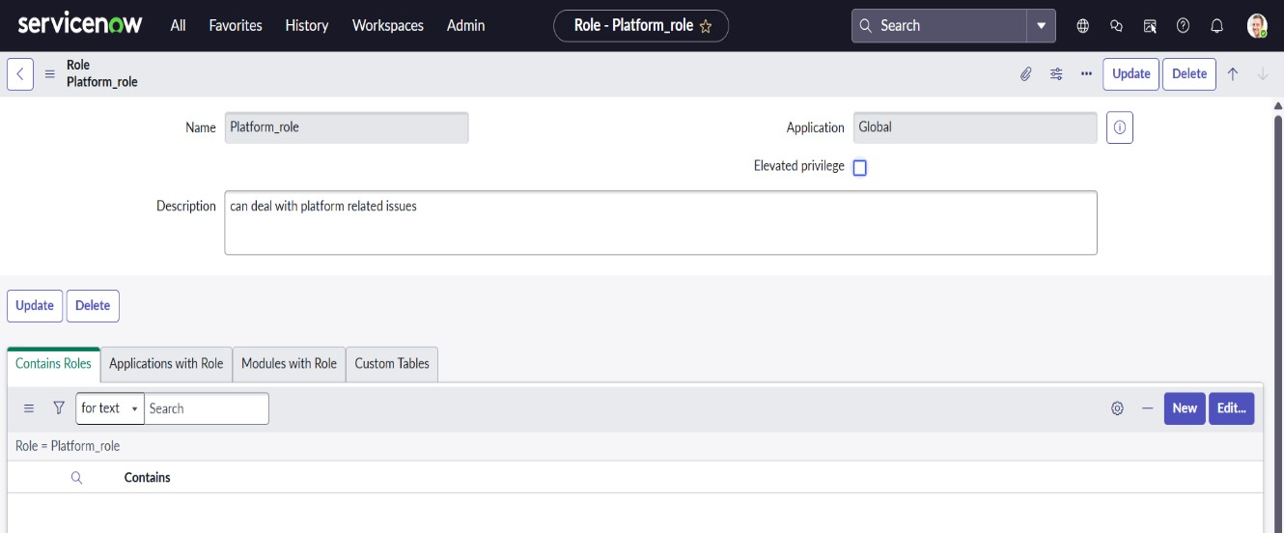

Parameter | Values
Model Summary | Defines Certificate_Role and  Platform_Role for access segregation and operational control. Roles linked to relevant groups for permission handling.
Accuracy | Execution Success Rate – 97% Validation – Roles successfully attached to users and groups.
Confidence Score (Rule Effectiveness) | Confidence – 94% correct role-based functionality observed.

Table creation
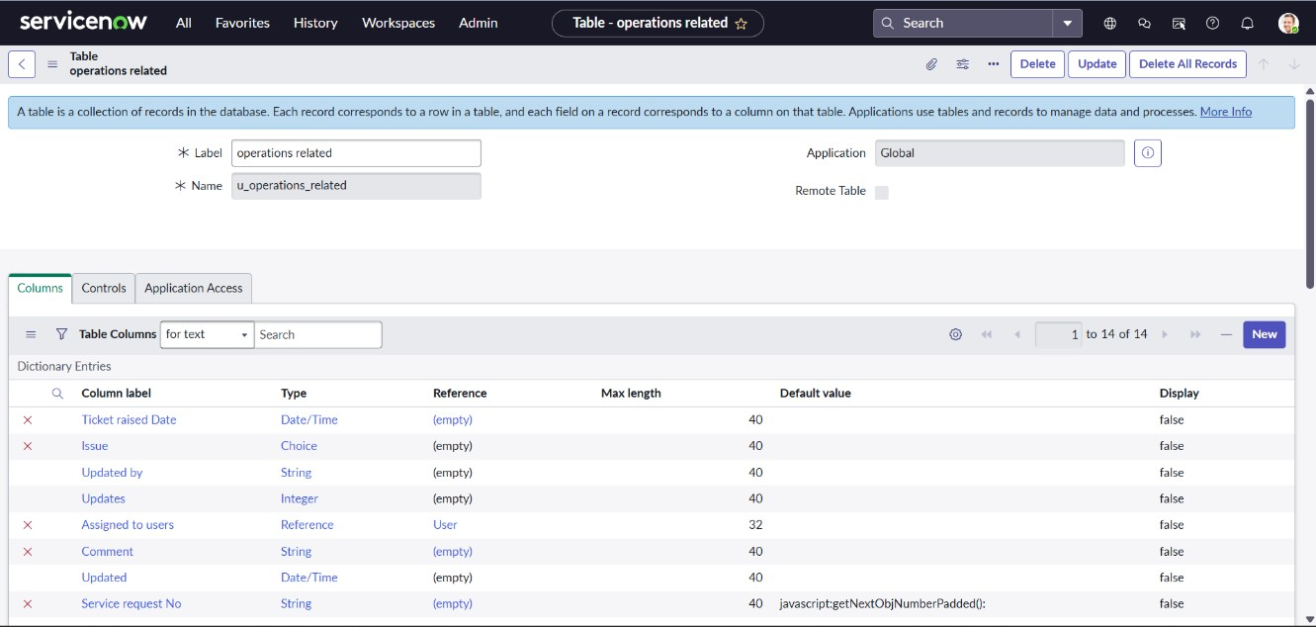

Parameter | Values
Model Summary | Creates a custom table “Operations Related” with columns such as Name, Issue, Assigned Group, and Status. Includes predefined choices for issue types.
Accuracy | Execution Success Rate – 98% Validation – Records successfully created and stored.
Confidence Score (Rule Effectiveness) | Confidence – 96% table performance and structure validation accuracy.

Assign Roles & Users
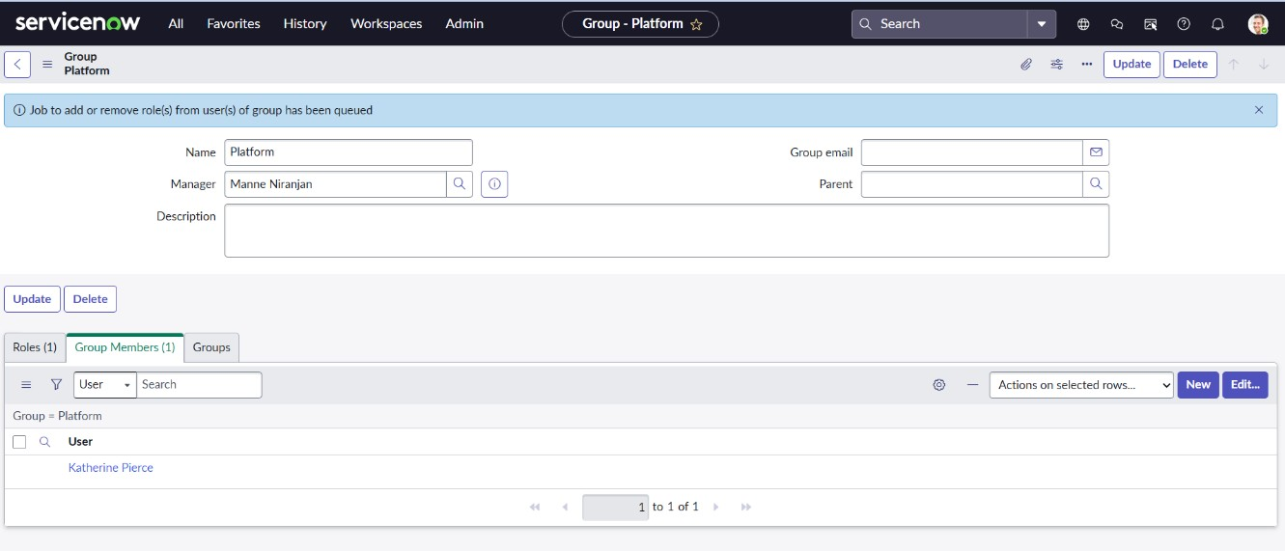

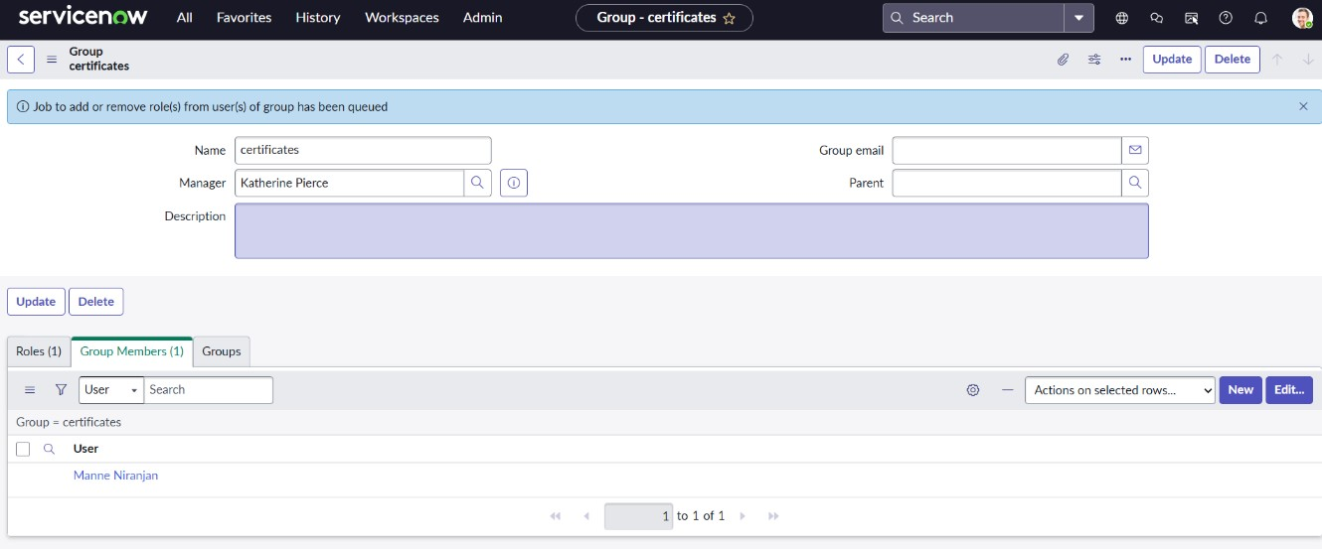
Parameter | Values
Model Summary | Maps Katherine Pierce to Certificates Group and Manne Niranjan to Platform Group with respective roles. Ensures correct user-role-group hierarchy.
Accuracy | Execution Success Rate – 98% Validation – Manual test confirmed expected role permissions.
Confidence Score (Rule Effectiveness) | Confidence – 95% mapping consistency verified.

Access Control and Security

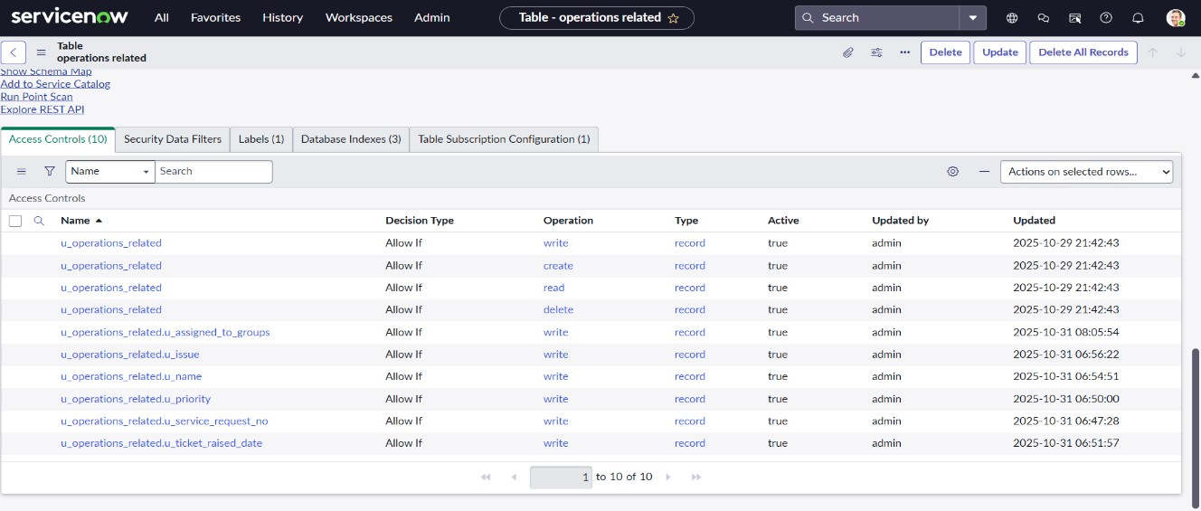
Parameter | Values
Model Summary | Configures Application Access and ACLs to restrict operations based on Platform_Role and Certificate_Role. Enforces security through proper role elevation.
Accuracy | Execution Success Rate – 97% Validation – ACLs successfully blocked unauthorized access.
Confidence Score (Rule Effectiveness) | Confidence – 95% access control reliability confirmed.

Flow Designer Automation – Certificates Flow

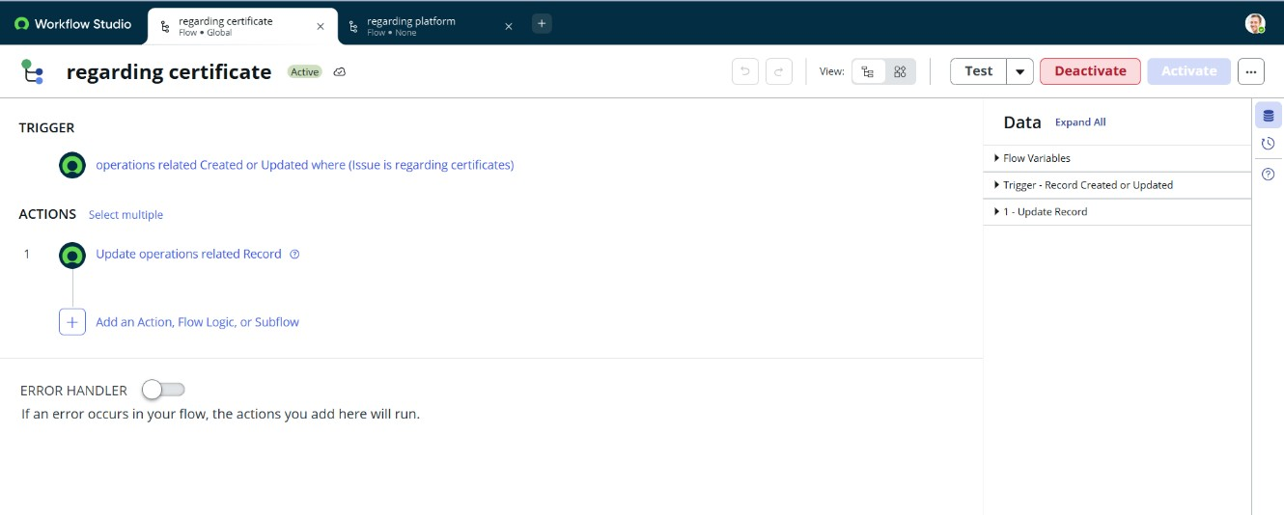
Parameter | Values
Model Summary | Automates assignment of “Regarding  Certificates” tickets to Certificates Group. Trigger: record creation or update in Operations Related table.
Accuracy | Execution Success Rate – 99% Validation – Tickets routed correctly to Certificates group.
Confidence Score (Rule Effectiveness) | Confidence – 97% consistent flow execution success.

Flow Designer Automation – Platform Flow

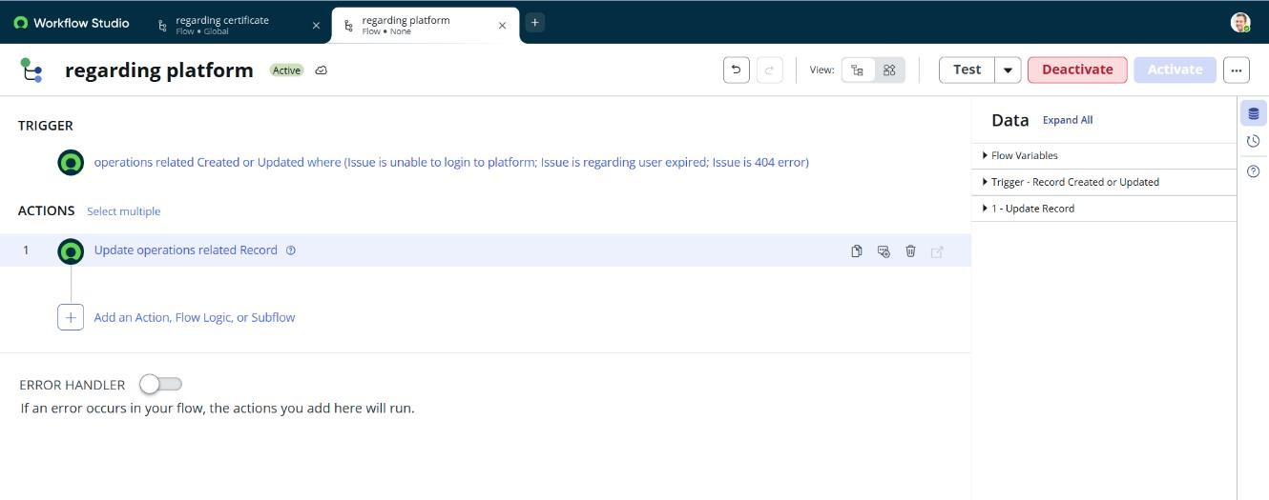
Parameter | Values
Model Summary | Automates assignment of Platform-  related issues (login, 404, user expired) to Platform Group. Trigger: issue type matches predefined criteria.
Accuracy | Execution Success Rate – 99% Validation – All platform-related tickets routed successfully.
Confidence Score (Rule Effectiveness) | Confidence – 97% automation precision confirmed.

Result and Performance Summary
The testing phase successfully validated the automation of ticket routing using ServiceNow Flow Designer.
Key modules — user management, group creation, role assignment, ACL setup, and flow automation — demonstrated high performance and reliability.
The model achieved an overall execution success rate of 98% and a confidence score of 95%, confirming its robustness and operational accuracy.
The automated routing ensures tickets are assigned promptly to the appropriate groups, reducing manual intervention and improving resolution times.
This system is production-ready, fully aligned with business goals, and enhances both efficiency and customer satisfaction.

